**Ornamentally**

**Turned**

**Finials**

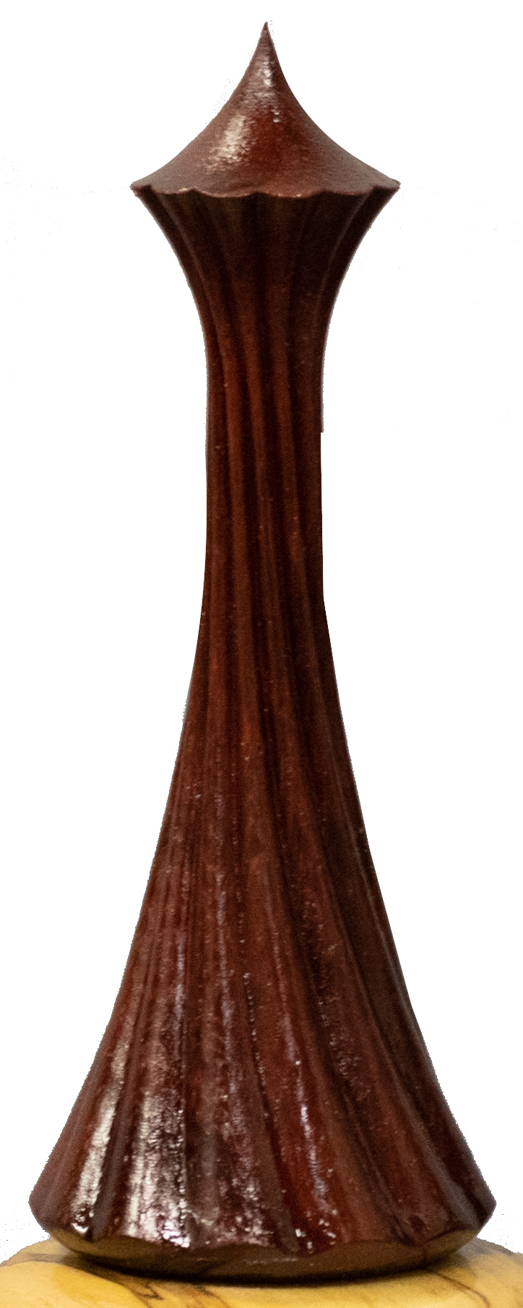

Rich Colvin

01 December 2023

This book is intended to help you develop ornamentally turned finials in a way that results in an outstandingly pleasing shape.

Good luck

Rich Colvin

Table of Contents

Finials Defined 4

Common Design Elements 5

Unique Design Elements 6

Parts of a Finial 7

Crown 7

Body 7

Base 7

Collar 8

Size of a Finial 9

Height of the Finial 9

Diameter of the Finial 10

Wood Selection for Finials 11

Wood Color 11

Multiple Elements 11

Rosettes Used for Finials 12

Process for Turning a Finial 13

Step 1 – the Crown 15

Step 2 – the Body 18

Step 3 – the Base 25

Optional Step – the Collar 26

Bamboo Finial 27

Fluted Finial 29

Helically Wrapped Finial Type 1 30

Helically Wrapped Finial Type 2 33

# Finials Defined

Finials have a long history in architecture and furniture, and these are all well-defined. They can be found on buildings built as long ago as 700 AD in Asia. As people travelled around, they must have made their way to the rest of the world and are a prominent feature of Gothic architecture.

Finials evolved over time to include structures like spires, pinnacles, and minarets. In the end, they are a way to decorate a part of the structure which reaches for the sky. Finials typically point upward but can also point downwards. When pointing down, they are called pendant finials.

It should be noted also that architectural finials are not always long and spindly. Some common ones include acorns and pineapples which are commonly seen atop fences or balusters for stair rails.

In the world of non-functional woodturning (i.e., woodturning to make objects not used for architectural use), the first commentary I can find to ornamentally turned finials is in Turning and Mechanical Manipulation, vol. 5 - The Principles and Practice of Ornamental or Complex Turning by John Jacob Holtzapffel (1884). You can see examples below.

The first two pictures show items with finials. Holtzapffel gives instructions on how to make these in this treatise.

|  |  |
| --- | --- |
| Plate VI. Toilet Ring Stand | Plate XLVI. Ivory Tripod Vase |

And these two pictures show elements for finials.

|  |  |
| --- | --- |
| Plate VIII  Items 195, 196, & 197 | Plate LIV  Item 580 |

Cindy Drozda ([www.CindyDrozda.com](http://www.CindyDrozda.com)) is one of the prominent artists making and teaching about turning finials on traditional lathes. She has done a great job outlining a style & design for them.

When comparing the traditionally turned finial (such as those from Cindy Drozda) with an ornamentally turned finial, there are some commonalities.

## Common Design Elements

* The elements must be crisp and elegant.
* The finial should complement the vessel it is atop, and not overpower it.

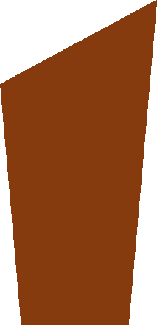

* A finial should have no straight surfaces; everything should be curved when viewed from the side. There is an exception when the top of the finial is flat and cut at an angle. (If the top were flat, it would be a knob, not a finial). An example is shown to the right. This is a common design seen on pieces with an Asian flair.

And there are Design Elements which are unique.

## Unique Design Elements

|  |  |
| --- | --- |
| **Traditionally Turned Finials** | **Ornamentally Turned Finials** |
| * The finial should be delicate and light – so much so that you should be afraid to touch it for fear of possibly breaking it. * The finial may incorporate the vessel’s shape into its shape. | * The finial’s size should be sufficient so as to not make the ornamental turning look sloppy or ragged.   This oftentimes means the diameter will be larger than one outlined by Cindy Drozda: ½” is not uncommon. |

# A picture containing venn diagram Description automatically generatedParts of a Finial

An ornamentally turned finial consists minimally of 3 parts:

* A **crown** at the top. It is the part reaching up towards the sky.
* A **body** which may be made from multiple segments.
* A **base** which is designed to elevate the finial up from the piece, separating this design element from the vessel.
* A **collar** can be added optionally.

## Crown

The crown of a finial is typically a single conical shape, though there are some instances where it may be multiple conical shapes. In either case, it should be the last part of the finial which you see as you gaze up from its base to the top.

The bottom of the crown is flared out to separate it from the body below, giving clear delineation.

Unless making a triple finial (as popularized by Gorst du Plessis), make the crown a conical shape using a cutting frame. A large radius cutter (1” or so) is recommended for turning this.

## Body

Note the picture to the right, and how the angle between the base of the crown and the top of the body is >90º. When this is very acute, the shape can resemble the Seattle Space Needle.

**Traditionally Turned Finial**

More importantly, it can be difficult to cut this without the perimeter being ragged. In either case, if that is not the desired design, ensure the angle is not acute.

In traditional finials, the lower part of the finial is where the “onion” bulb is typically put. From there, it tapers up to the crown. In ornamental turning, this body can have many different shapes as discussed below, but the general idea is that that top of the body will be smaller in diameter than the bottom.

## Base

A good base can be achieved many ways, and some ideas are discussed below. It generally needs to be small in height but will be the greatest in diameter.

## Icon Description automatically generatedCollar

A collar is an optional element which can be added when a

small finial is added to a large vessel. It sits between the

finial’s base and the vessel and helps to break up the design.

It can also cover a large opening in the vessel.

One is shown to the right as the orange piece.

I have used collars when the vessel was quite large, and a finial would either get lost or be too large & clunky.

A collar can also be used to break up the color pattern. For example, a dark brown vessel would not display a black wood finial; however, a light-colored collar could provide the break between the two.

# Size of a Finial

The overall size of a finial needs to be in proper proportion to the vessel on which it is placed.

## Height of the Finial

The golden ratio is a good starting point for determining the height of the finial. That ratio is usually represented by the lower-case Greek letter phi (**ϕ**) and has a value of about 1.618.

The typical approach is to use the ratio so that the height of the finial is the 1 and the height of the vessel is **ϕ**.

|  |  |  |
| --- | --- | --- |
| Finial Height | = | 1 |
| Vessel Height | ϕ |

And this can be re-written as:

|  |  |  |
| --- | --- | --- |
| Finial Height | = | Vessel Height |
| Φ |

For a 4” high vessel, this would make the finial’s height to be

|  |  |  |
| --- | --- | --- |
| Finial Height | = | 4” |
| ϕ |
|  |  |  |
|  | ≅ | 2.47” |

or roughly 2 ½”. And since the golden ratio is used for planning, 2 ½” is a good size to use.

For shorter, fatter objects, the ratio could be reversed

|  |  |  |
| --- | --- | --- |
| Finial Height | = | ϕ |
| Vessel Height | 1 |

but that would make for a very tall finial. It would take a very special design to accommodate such a tall finial.

## Diameter of the Finial

With a traditional finial, the finial’s diameter for the parts is set with a line from the top of the crown to the fattest part of the base as shown to the right.

My experience with ornamentally turned finials does not keep true to that idea. Instead, I have found the most pleasing shapes have a body which is slightly larger than expected when using the traditional approach outlined above.

In any case, the overall diameter of the finial must not make it look heavy or clunky. It needs to be as light as the ornamentation will allow.

However, also do not cut the diameter to thinly for the selected rosette.

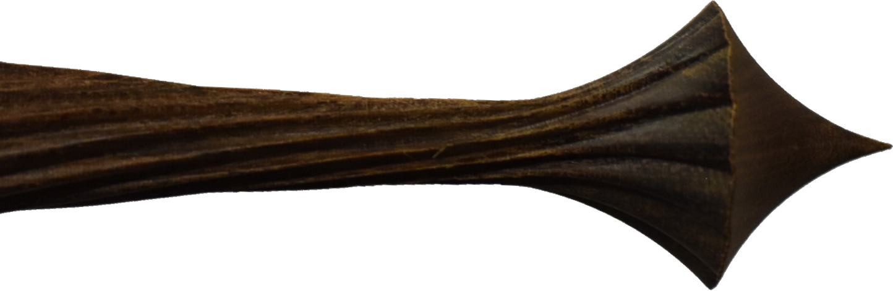

As shown in the picture to the left, it can get very ragged looking. The area in the red box is particularly bad.

This was made using an amplitude adjuster set at 50%, and the diameter at the narrowest point is ¼”.

# Wood Selection for Finials

The wood used for a finial needs to have straight & tight grain. It should also be a very hard & dense wood. The selected wood will need to:

* Take a shape well, keeping in mind that the shape is going to be small.
* Not chip when being cut.
* Not detract from the finial’s shape. This is where woods which have large pores or are highly figured are not usually the best choice.

Examples of woods often used include:

|  |  |  |
| --- | --- | --- |
| * African Blackwood * Bloodwood * Boxwood * Dogwood | * Holly * Madrone * Hard Maple | * Pear * Pink Ivory * Rosewood |

I have found that other woods are useful for the collar. Some I have used include:

|  |  |  |
| --- | --- | --- |
| * Ash | * Soft Maple | * Yellowheart |

These worked acceptably as the part is so large (relatively) that the presence of the grain is not problematic.

## Wood Color

The color of the wood used for the finial needs to be a good contrast to the wood used for the vessel. Generally, it should not blend into the element. That said, some pieces made via fixed tool work do have all the elements from the same material.

## Multiple Elements

In ornamental turning, is is very common to make a finial from multiple pieces of wood rather than trying to turn the final shape from a single piece. An example of where this is required is when incorporating an element of nested spheres.

When a finial is made from multiple pieces of wood, great care must be taken to ensure that the pieces appear to be a single piece when assembled.

There are some cases where this guideline may be violated. For example, you might choose to embed one wood inside another so that the ornamental cutting exposes it in interesting ways.

# Rosettes Used for Finials

When considering which rosettes to use for the pieces of a finial, paper chuck drawings can be quite useful. This will help to envision what the shape will look like at such small diameters. Some examples of these are below.

Certainly, the use of an amplitude adjuster will help to smooth out some of the bumpiness, but that can only do so much. In the end, rosettes which produce points should be avoided.



The point produced by the F rosette almost looks knife-like, especially when the diameter is quite small as shown in the Holtzapffel F3 rosette pictured to the right.

The points in this shape are not pleasing to the eye and will be difficult to execute in a way that they do not look ragged.

Rosettes I have found to produce pleasing shapes include:

|  |  |  |
| --- | --- | --- |
| **Holtzapffel A Series** | | **Holtzapffel D Series** |
| **GDP-3** | **Plain Series**  (Rubber on the back side; P-3 and P-4 shown) | |

# Process for Turning a Finial

Once I’ve decided on an overall shape, size, wood to use, and rosettes, I will usually make a prototype first. This helps me ensure that the shape is what I want and ensures the process I am going to use will work.

#### Amplitude Adjuster

An Amplitude Adjuster is usually employed when making finials. Rosettes have a large amplitude when used for items with small diameters, and the design needs to be fit to the finial’s planned diameter.

#### Curvilinear or Linear Slide

A Curvilinear or Linear Slide is another key piece of equipment when making most finials. There are some which do not need this. One is discussed below (the Bamboo Finial). Variations on that theme can also yield nice pieces.

#### Cutter

Which cutter gets used can have a great impact. If there is a need to cut deep grooves, a fly cutter with a 30º point angle; otherwise, the 60º point angle may work acceptably.

#### Cutter Angle and Alignment

Some designs need the cutter rotated from horizontal to a different angle. When such rotation is made, you will need to ensure the cutter is vertically aligned as desired for your planned cuts.

|  |  |
| --- | --- |
| Cutter Alignment  as seen from operator side | A picture containing diagram  Description automatically generatedCutter Alignment  as seen from the outboard side |

|  |  |
| --- | --- |
| Cutter Aligned above spindle’s axis of rotation | Cutter Aligned  on spindle’s axis of rotation |

When aligned above the axis, the resulting cuts will be as shown as in the red figure to the right. Aligning below the axis would flip this picture.

When aligned vertically with the axis, the resulting cuts will be as shown in the green figure to the right.

#### Work Holding

When I make finials, I like to use a Beall collet chuck.

* The Beall collet chuck can be affixed to a threaded adapter which has a #2 Morse taper. The adapter I use has 1 ¼”-8 threads, same the Beall collet chuck.
* This adapter needs to be one with a draw bar (usually ⅜”-16 threads) for holding it in the headstock.
* The Morse taper on the adapter allows for moving the piece between machines with little or no noticeable run-out.

|  |  |  |
| --- | --- | --- |
|  |  |  |
| Draw Bar | Threaded Adapter | Beall Collet Chuck |

Once I get a suitable piece of wood roughly rounded to a cylinder, I put a tenon on the end for the collet chuck to hold it. The Beall collet chuck uses ER32 collets, so I typically use a ¾” diameter tenon. That turned piece is then attached to the Beall collet chuck.

Now the wood can be turned down to a shape close to the final shape, reducing the amount of time required on the rose engine lathe. Making any further refinements to the piece whilst held in the collet chuck helps to minimize issues when the whole thing is moved to the rose engine lathe. Be sure to use a draw bar to ensure everything does not come loose from the lathe.

The steps below are in regard to the work on the rose engine lathe.

## Step 1 – the Crown

Start with the finial’s crown.

The crown is usually a part of the same piece as the body. If this is the case for the one you are making, there are no designs needed for attaching it to the body.

The crown is the point furthest from the headstock. The added material between the crown and the headstock helps support the cutting activity, providing for a better finished surface.

I will usually set the rose engine lathe to turn without the use of a rosette and cut the crown using a horizontal cutting frame. This produces a nice, smooth, concave curve. If you opt for using a rosette for this surface, a prototype is highly recommended to confirm the shape achieved is what you’d like.

**Critical Note:** the cutter must be vertically aligned so that it cuts at the axis of rotation. Otherwise, a crisp point will not be achieved at the tip of the crown.

I like to use a cutter which has a 1” radius in its swing. The arrow on the swing path shows the direction of rotation for the cutter.

#### Factors Affecting the Shape of the Crown

1. The diameter of the cutter’s cutting path.
2. How far the cutter is advanced into the piece.

|  |  |
| --- | --- |
| Icon  Description automatically generated  When the cutter is advanced to axis of rotation, this yields a very acute angle at the end.  The sharp end at the point of the finial can be easily damaged. | Icon  Description automatically generated  When the cutter is advanced past the axis of rotation, this yields a much wider angle. |

##### Example 1

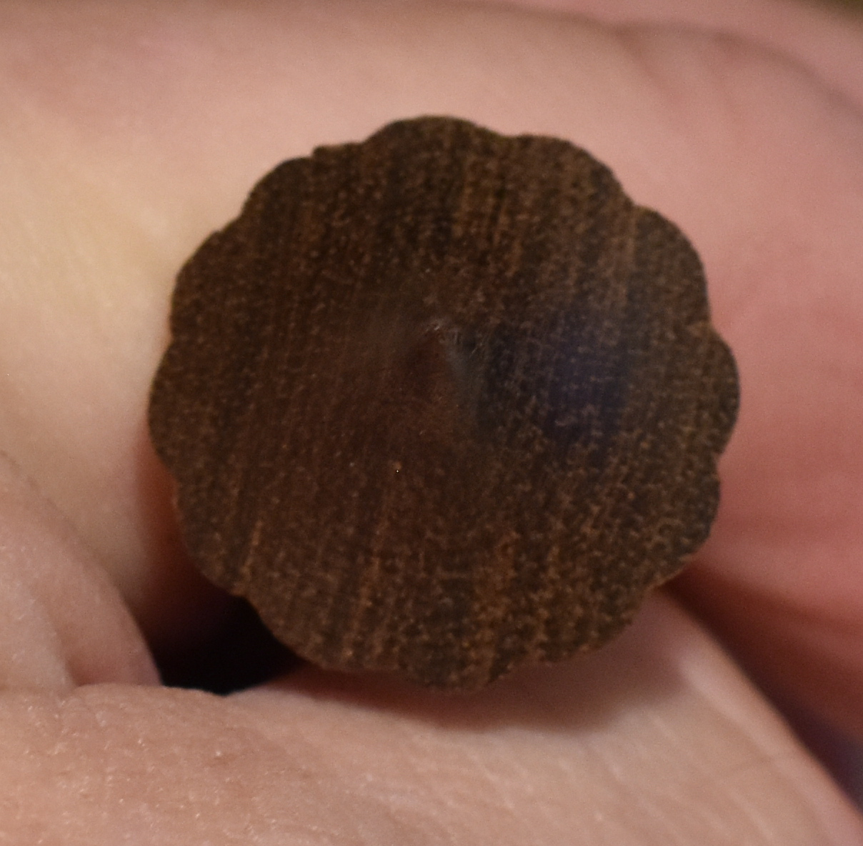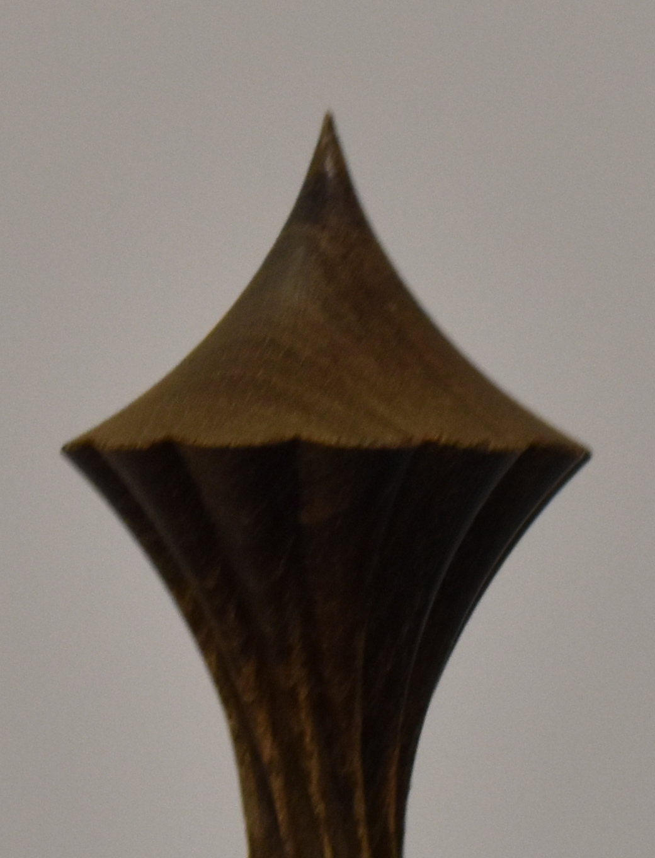The body is made using a D-12 rosette, and this makes a nice design when viewed from the top.

The transition between the crown and the body is about 90°.

Overall, this is a nice design.

##### Example 2

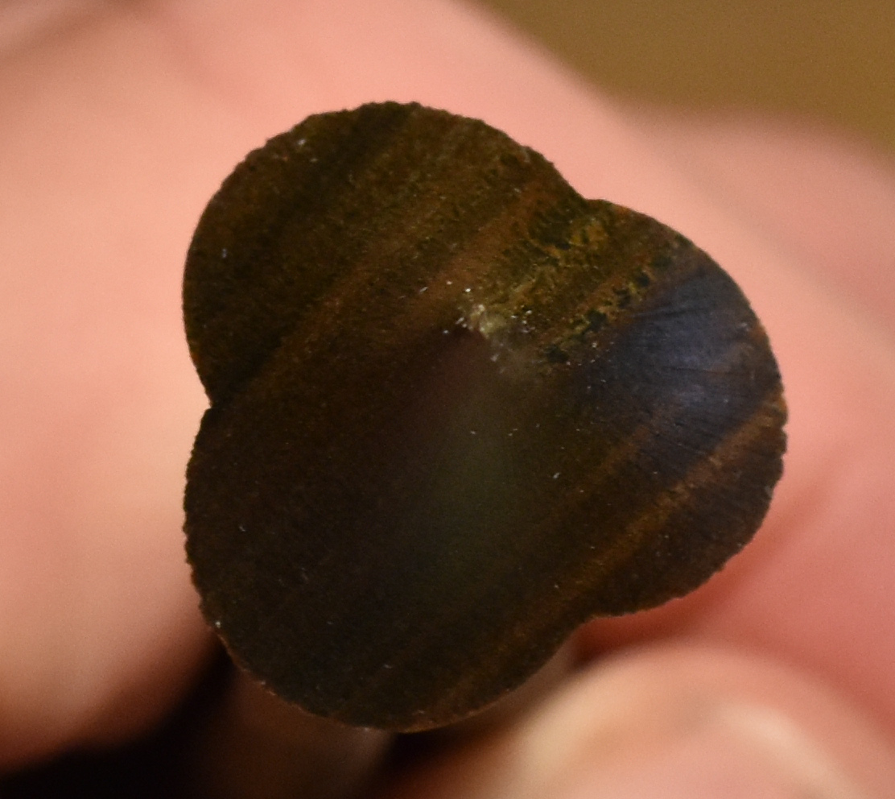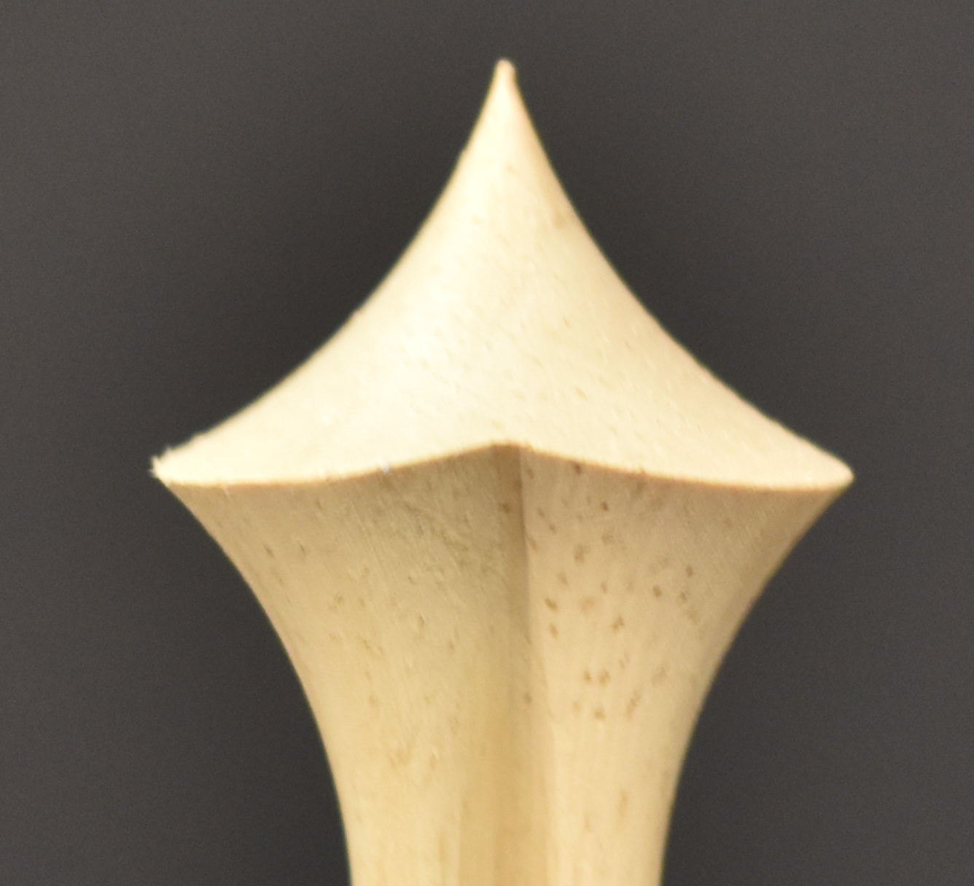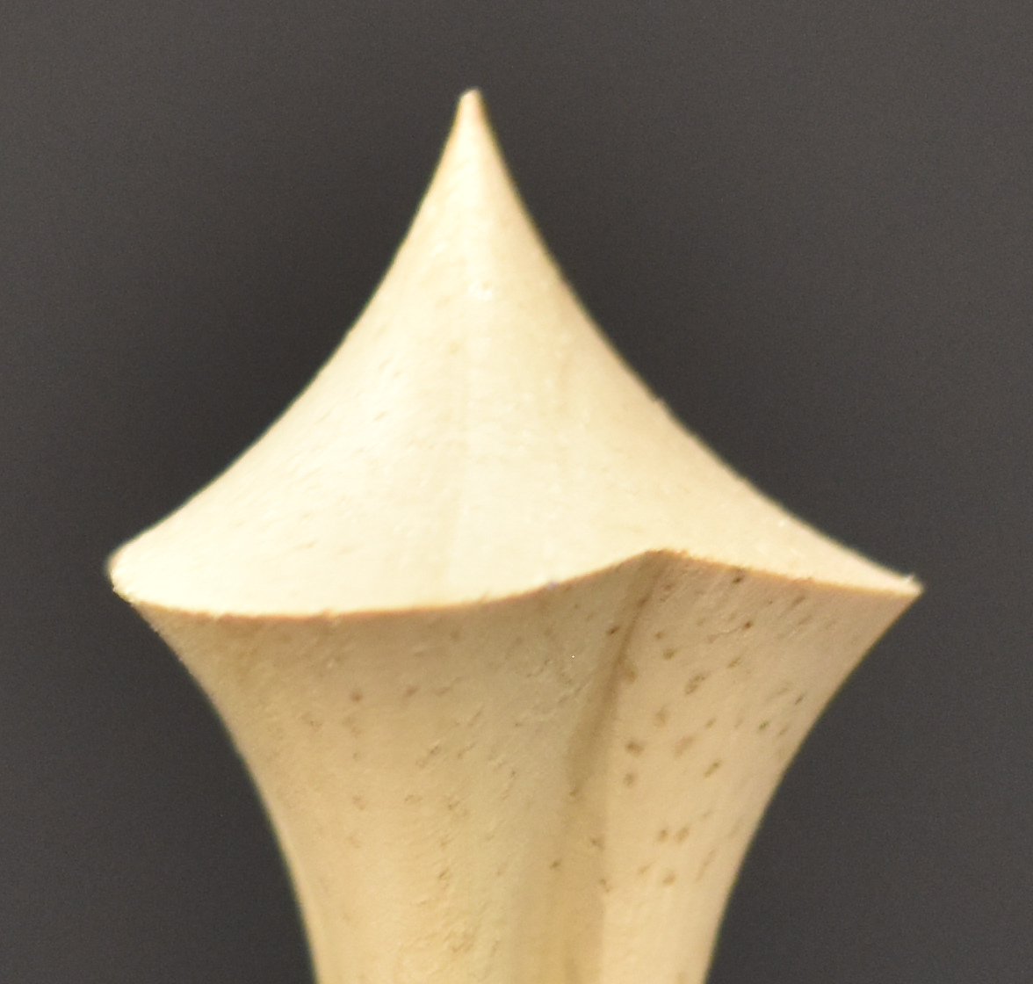The body of these were made using the GDP-3 rosette and makes a more distinct design when viewed from the top.

The transition between the crown and the body is also about 90°.

The pictures to the right show it from the side from two angles of rotation. This too is an overall nice design.

##### Example 3

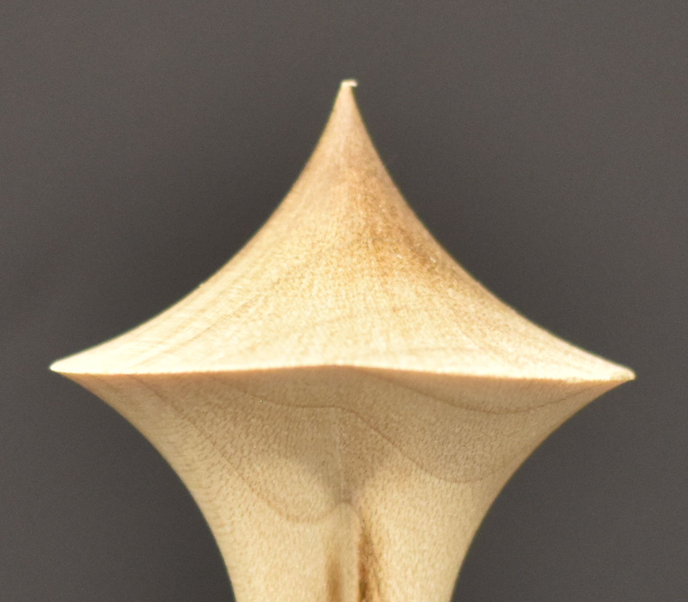This finial has a very sharp angle between the crown and the body and resembles the Seattle Space Needle. Also, the edge at that transition is very fragile.

This is not recommended.

##### Example 4

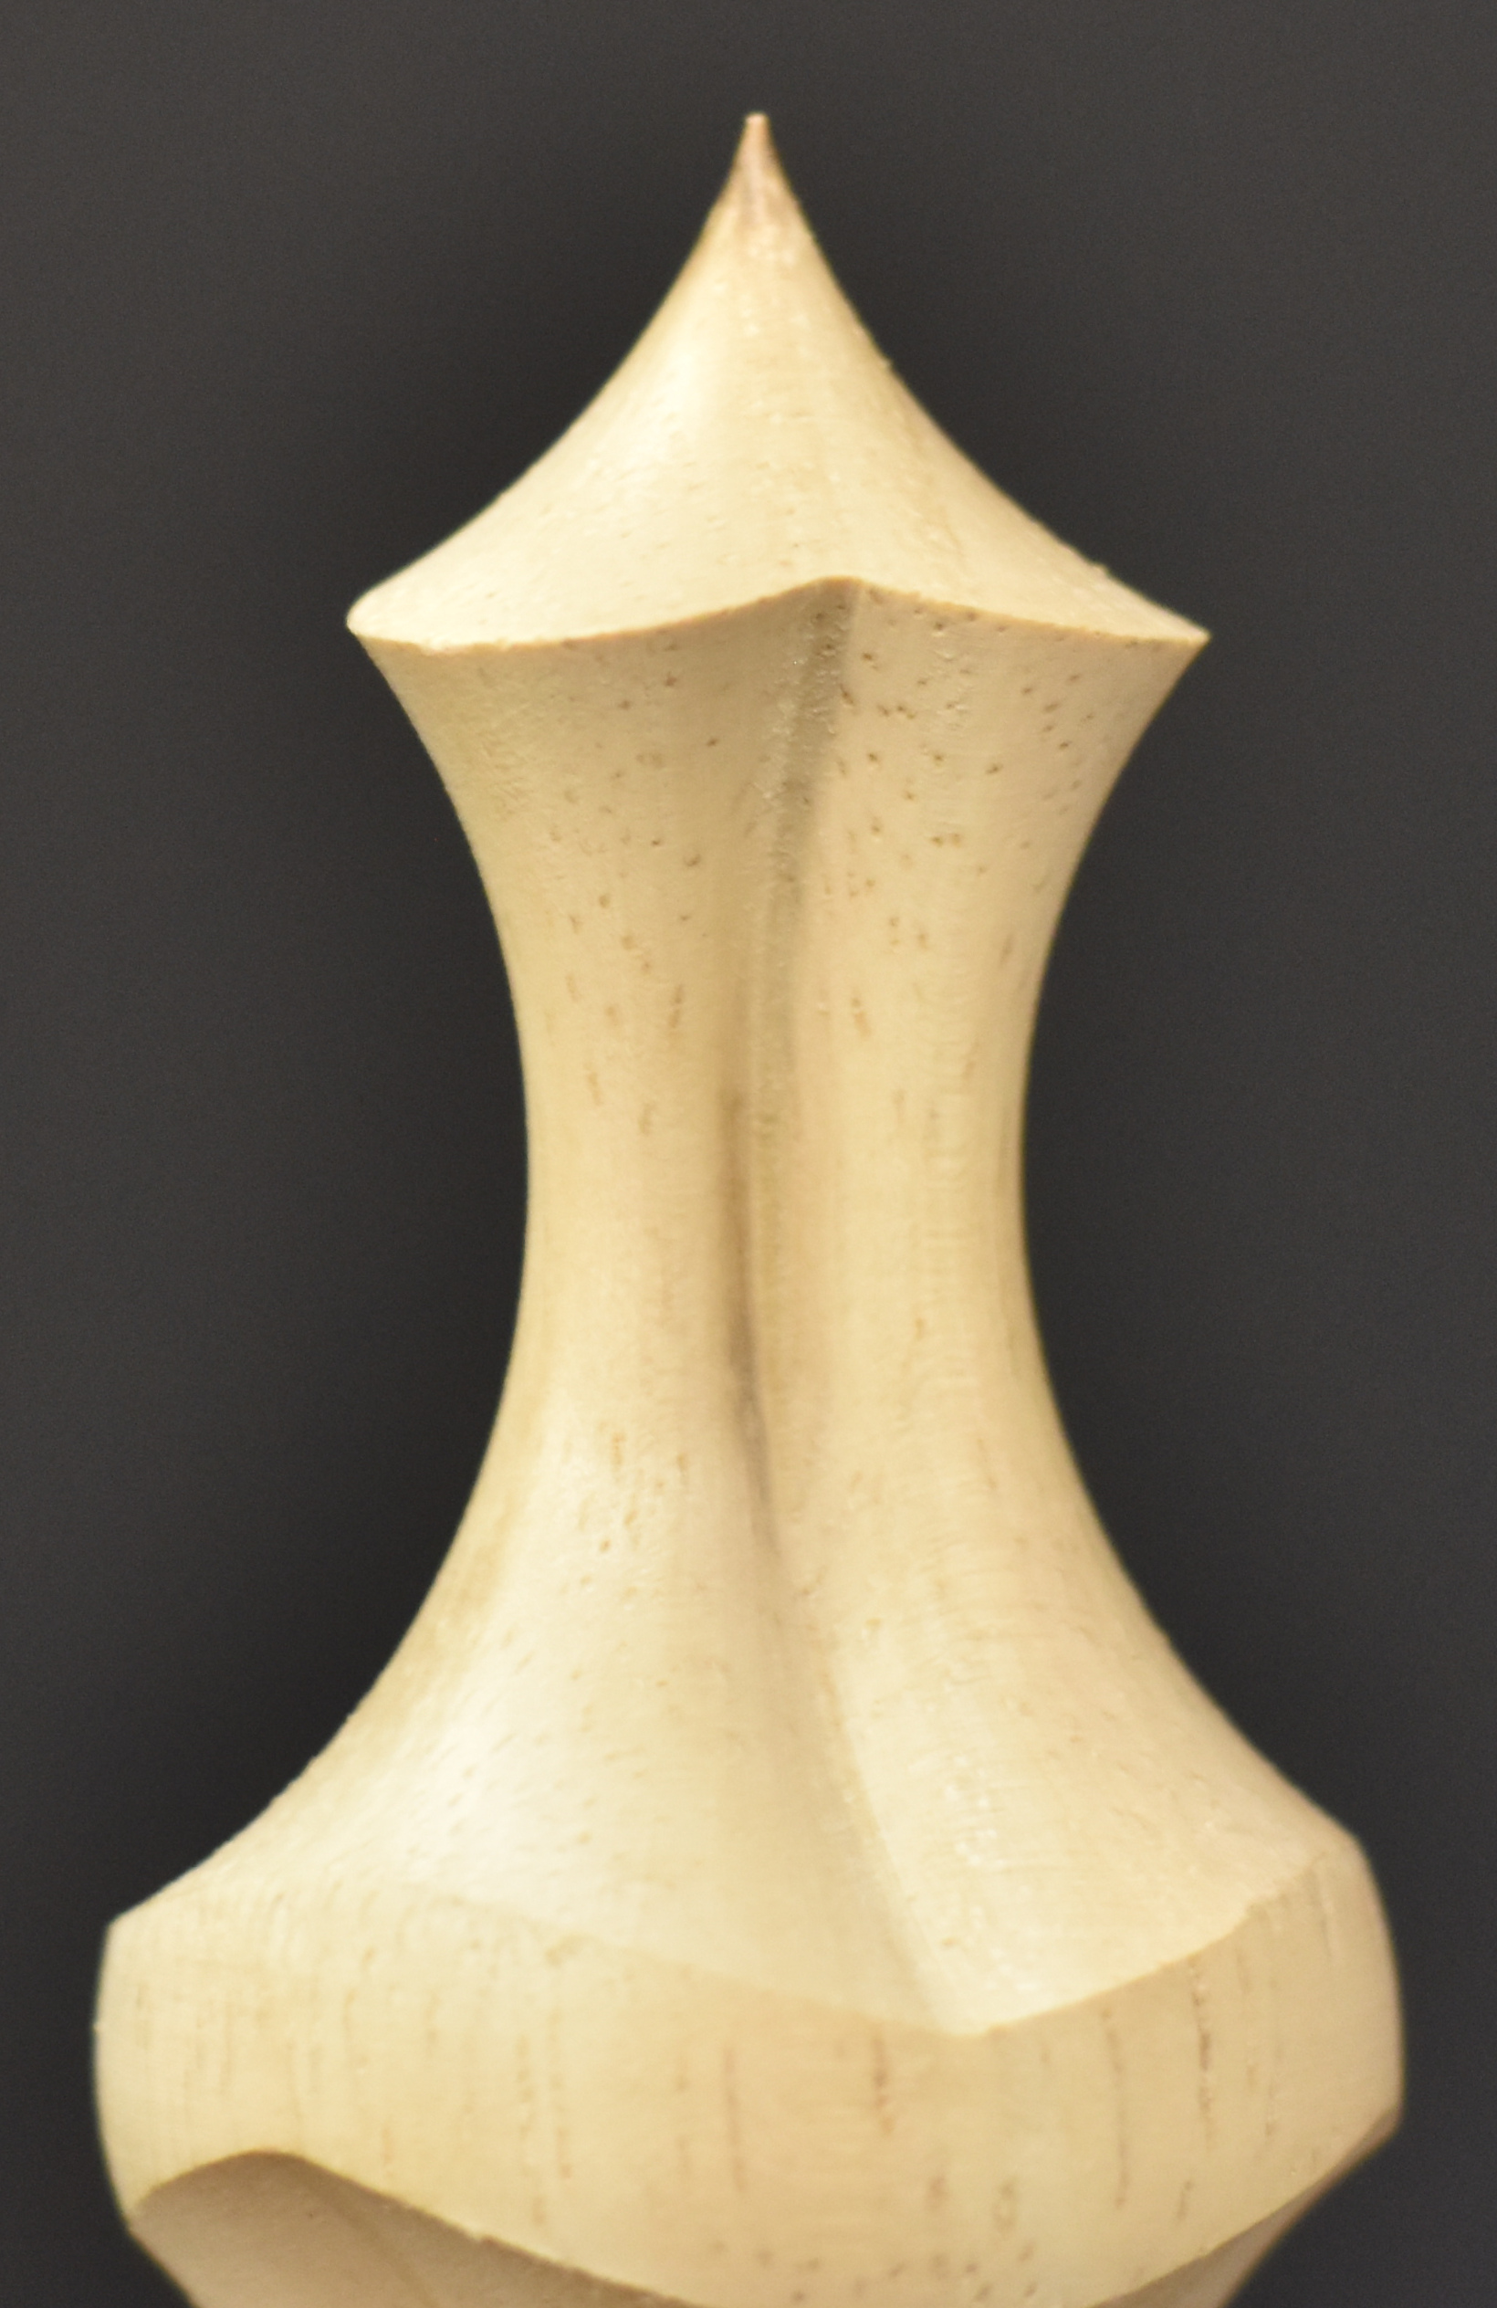This finial has a transition between the crown and the body which is greater than 90°. This may seem a bit large of an angle, but it fits with the overall design of this bamboo finial (more about that style starts on page 27).

This is an overall nice design.

## Step 2 – the Body

The body is where the ornamental turning really makes the finial very different from one turned traditionally. Options for that shape are outlined in cases below.

#### Preparing to Turn the Body

**Step 1**

Ensure the cutter is turning the correct direction. This will be the opposite of how it was used for the crown, as this will make for a better cut along the edge where the crown meets the body.

**Step 2**

|  |  |
| --- | --- |
|  |  |
| Direction of cutter rotation for a left helix. | Direction of cutter rotation for a right helix. |

Ensure the cutter is set at the correct angle. For some cuts, it will not be horizontal.

Given the choice, I prefer the left helix. This throws the wood chips down, making less of a mess in my shop. But that is not always an option.

**Step 3**

Ensure the cutter is vertically aligned unless your design is to do otherwise.

**Step 4**

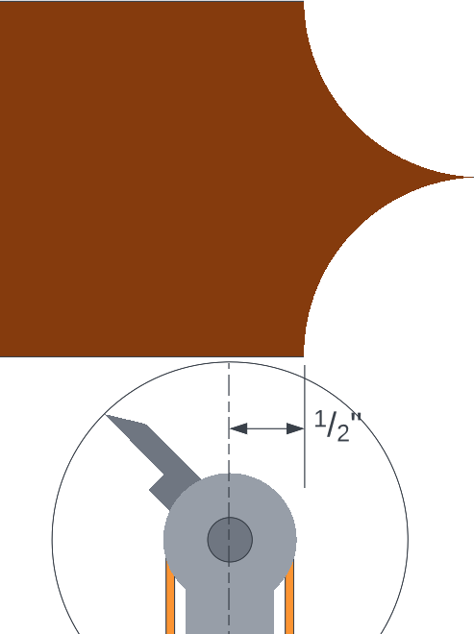Select where to start turning the body. This determines the angle between the Crown and the Body and is key to the overall design of the transition from the crown to the body.

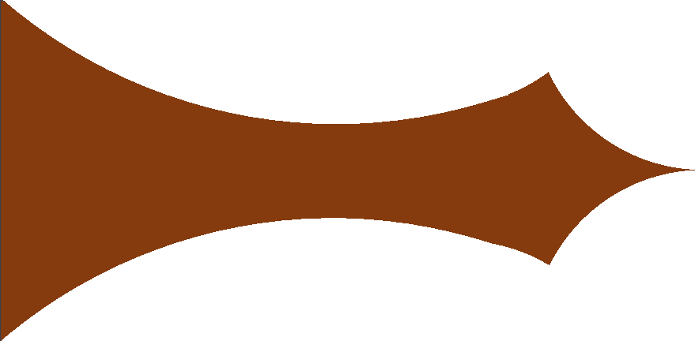As shown in the picture to the left, the swing of the cutter should overlap the swing of the cutter for the Crown. If the center of the HCF is started about ½” to the left of the finial Crown’s end, the transition will usually result in a good shape – something like the picture to the right.

**Key Note:** As noted above, the direction of rotation for the cutter needs to be reversed for the body.

**Step 5**

For the synchronized movement. Set the values as necessary.

For the length of cut, consider making the ornamented area longer than you will need. This allows for some to be trimmed off when cutting the Base.

The **Dynamic Rosette Phasiing calculator** is recommended for MultiSync values, especially for the Spindle and M3 Targets, This will become key if you take a series of roughing cuts to get close to the final diameter before setting up for the final cut.

When moving from a step-over of 0.100” to 0.010”, it is easy to believe that the Spindle Target and M3 Target should be simply multiplied by 10. That will fail.

|  |  |  |
| --- | --- | --- |
|  | Roughing Cuts | Final Cut |
| Stepover | 0.100” | 0.010” |
| Spindle Target | 7,200° | 72,000° |
| M3 Target | 7,110° | 71,910° |

For example, with 90° left helical wrap-ping of the rosette’s pattern across 2”:

This is because

M3 Target = Spindle Target - 90°

**Step 6**

Ensure the cutter can move horizontally along the desired length, and not move past the end of the template on the curvilinear slide.

#### Stepover Explained

Stepover is how far the cutter moves along the Z axis during a single revolution of the spindle. This is shown in the pictures to the right, with the swing of the cutter shown as circles.

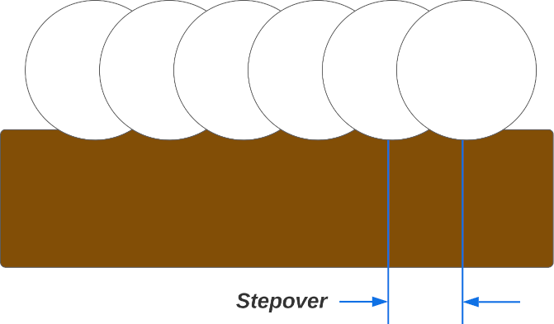When the stepover amount is “large”, then the surface will show marks of the cut path. This is a useful way to make cuts when roughing out the shape as it is faster. Indeed, these may even be made with a higher speed for the spindle’s revolution.

**What is “large”?** 0.100”

Alternatively, when the stepover amount is “small”, the path mark will be virtually invisible to the naked eye. The surface will appear to be smooth.

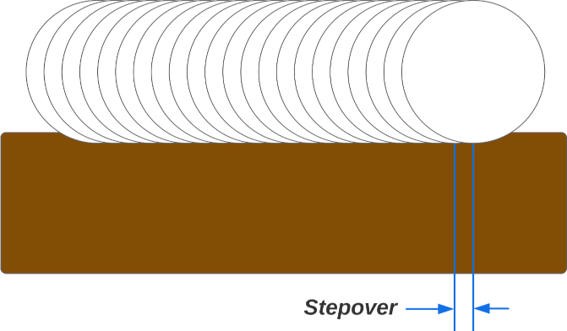**What is “small”?** 0.005” is common, but this can be even smaller.

I use a small stepover with a very slow spindle speed for the final pass. Such endeavors can easily make that pass last 2-4 hours, so the automation provided by synchronizing stepper motors makes this possible.

Stepover may be a part of the design of the piece. The cut will be a spiral wrapped helically around the piece. Sometimes this makes for a great design choice, and an example of that is shown on page 24.

#### Process – Using Sync

**Sync**

|  |  |
| --- | --- |
| Topic | Use This Value |
| Length of the cut | Distance |
| Amount of spindle rotation across that length.  For roughing, this is 10 x Distance (in inches). So, a distance of 1” has 10 revolutions which equals a stepover of 0.100”.  For the final pass, this is 100 x Distance, or greater. For a distance of 1”, this equals a stepover of 0.010” or less. | Revolutions |
| Set the speed for the Z axis at 100%. |  |
| Set the speed for the spindle at what makes sense for the roughing cut, and then decrease it for the final pass. |  |

|  |  |  |
| --- | --- | --- |
| Step | Function | Instruction |
| 1 | Index | Set the index amount (e.g., 5 divisions of a circle).  Set the index speed to be slow. Recommend 30-50% with a max speed of 5,000. This will come into play with step 6. If it is too fast, the cut will be ragged. |
| 2 | Main | Set the cutter to start at the starting position. Run a series of cuts to cut the area below the crown around all 360° around the piece.   1. Start the cut at the starting position. 2. Whilst rotating the piece with the rosette engaged, move the cutter into the piece, developing a depth of cut 0.050” to 0.100”. |
| 3 | Sync | Run the cut along the axis, moving towards the headstock. |
| 4 |  | Stop the cutter from running. |
| 5 | Sync | Return the cutter to the starting point.  Re-start the cutter. |
| 6 | Sync | Text  Description automatically generatedIndex the piece. |
| 7 |  | If the final diameter has not been reached, re-run steps 2-6. |
| 8 | Main | Run a couple of revolutions at the bottom of the Base. |

#### Process – Using MultiSync

**MultiSync**

|  |  |
| --- | --- |
| Topic | Use This Value |
| Length of the cut | Z Axis Target |
| Amount of spindle rotation across that length. This is in degrees of revolution. | Spindle Target |
| Amount of rosette rotation across that length. This is in degrees of revolution. | M3 Target |
| Direction of movement for all the axes in movement.   |  |  | | --- | --- | |  | Is used for a left helix. | |  | Is used for a right helix. |   I prefer the left helix as this has the chips thrown down. With the right helix, the chips are tossed into the air all over the place.  **Key Note:** M3 and Spindle must be the same direction. | |  |  | | --- | --- | | Z |  | | M3 |  | | Spindle |  | |
| On the **Move** Screen, ensure **Distance** matches the **Z Axis Target** | Distance |
| Set the speed for the Z axis at 100%. |  |
| Set the speed for the M3 axis at 100%. |  |
| Set the speed for the spindle at what makes sense for the roughing cut, and then decrease it for the final pass. |  |

|  |  |  |
| --- | --- | --- |
| Step | Function | Instruction |
| 1 | Main | Cut 360° around the piece in the area below the crown.   1. Start the cut at the starting position. 2. Whilst rotating the piece with the rosette engaged, move the cutter into the piece, developing a depth of cut 0.050” to 0.100”. |
| 2 | MultiSync | Run the cut along the axis, moving towards the headstock.  **Synchronized Targets** |
| 3 | Main | Cut all 360° around the piece in the area at the bottom of the Body. |
| 4 |  | Stop the cutter from running. |
| 5 | Move | Return the cutter to the starting point. |
| 6 |  | If the final diameter has not been reached   1. Re-start the cutter 2. Re-run steps 1-5. |

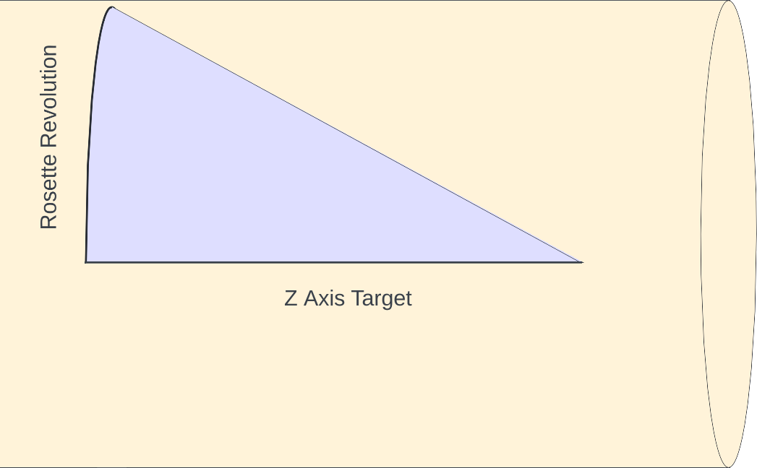The UCF will also have to be rotated when using MultiSync. This is necessary to align the cutter’s swing along the path of movement. As shown below, the cutter will move a certain distance along the Z axis, and also a certain amount around the circumference.

This is calculated using basic trigonometry as shown in the formula below.

|  |  |  |  |
| --- | --- | --- | --- |
| UCF Rotation° = tan-1 | ( | Rosette Revolution Distance | ) |
| Z Axis Target |

But be aware: If you are using a pattern template on the curvilinear slide, the rosette’s revolution distance is varying across the Z Axis target. For example, a template which generated the table below (values are in inches):

|  |  |  |  |  |  |  |  |  |  |
| --- | --- | --- | --- | --- | --- | --- | --- | --- | --- |
| Z Axis Target | 1.5 | 1.5 | 1.5 | 1.5 | 1.5 | 1.5 | 1.5 | 1.5 | 1.5 |
| Diameter | 0.955 | 0.900 | 0.850 | 0.800 | 0.754 | 0.704 | 0.659 | 0.614 | 0.573 |

Results in a varying rotation, depending on the diameter at that point

|  |  |  |  |  |  |  |  |  |  |
| --- | --- | --- | --- | --- | --- | --- | --- | --- | --- |
| Z Axis Target | 1.5 | 1.5 | 1.5 | 1.5 | 1.5 | 1.5 | 1.5 | 1.5 | 1.5 |
| Rosette Revolution Distance | 0.750 | 0.707 | 0.667 | 0.628 | 0.593 | 0.553 | 0.518 | 0.482 | 0.450 |
| Angle of Trough at Rosette’s Minimum Diameter | 21.4° | 20.3° | 19.3° | 18.2° | **17.2°** | 16.1° | 15.2° | 14.2° | 13.3° |

17.2° is the median number, so it was chosen for the UCF for this example. You can certainly choose a different value, depending on your artistic needs. More likely, an average of the Rosette Revolution Distance Max and Min would be used:

|  |  |
| --- | --- |
| Average Value = | 0.750” + 0.450” |
| 2 |
|  |  |
| = | 0.600” |

And at that distance,

|  |  |
| --- | --- |
| Angle for the UCF = | 17.4° |

As the UCF moves along the piece, it will only be aligned with the rosette’s minimum diameter at one point. This is depicted below where the red line showing the UCF cutter’s path is the same at all 3 points, but only aligned at one point. This results in a bit wider cut on the perimeters of the cuts.

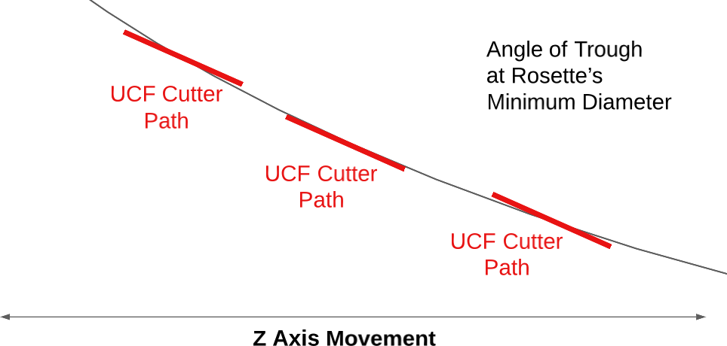And since we cannot dynamically change the UCF’s angle, we must select a Final Average Diameter somewhere in the middle. As noted, the trough will be wider to both sides of that point, but with a small enough stepover, it should not be terribly noticeable.

#### Multiple Segment Bodies

The body does not have to be made from a single piece. Indeed, the ones shown above from Holtzapffel’s book are certainly multi-pieced.

#### Finishing up the Body

If the body and the base are not the same piece of wood, the body needs to have a way of attaching it to the base designed into its final form.

##### Shape, icon Description automatically generatedVessel with a Large Mouth Opening

If the vessel has a wide opening, then the Base will need a large tenon to fit the Vessel’s opening (see the blue tenon on the Base extending into the brown vessel).

The tenon for the Body would then be inserted into the Base (see the green tenon on the Body extending into the Base).

##### Vessel with a Small Mouth Opening

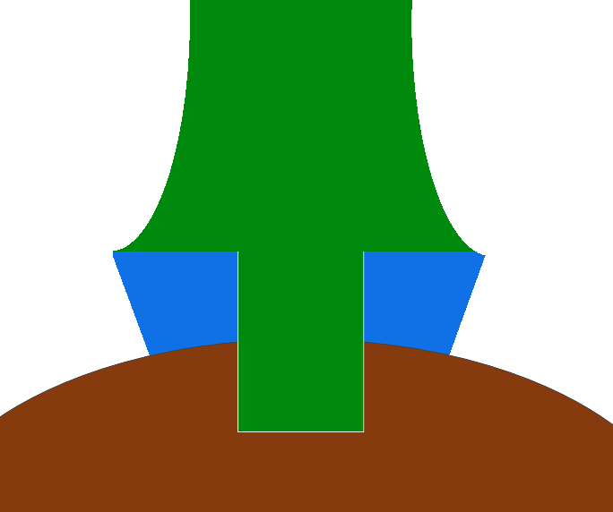However, if the vessel has a narrow opening, then the Body will need a long tenon to fit through the Base and into the Vessel’s opening (see the green tenon on the Body).

There would be no tenon on the Base. It would have a through-hole for the mortise.

**Key Note:** the drilling spindle and straight router bit are quite useful for precisely setting the diameters of the tenon and the mortise.

At the bottom of the base will be a tenon designed to fit the opening in the vessel. I prefer to have that tenon be snug, but not tight. Different woods react differently to humidity changes, and if it is too tight, it could end up cracking the vessel.

Conversely, if it is loose, then it will be constantly falling out whenever the vessel is picked up to examine it (or to clean the area around it). Either way, it will be annoying to the owner. And if it is too loose, it will be sloppy, and you have not put a good item into the potential owners’ hands.

## Step 3 – the Base

The base may be simple and designed into the same piece as the body.

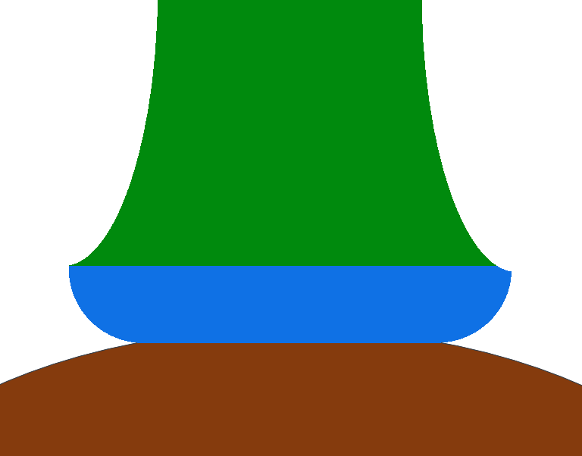

The drilling spindle and straight router bit are quite useful for precisely setting the diameter of the tenon.

One option I like to use here is to cut the bottom using a ¼” round-over bit (held in the drilling spindle). This way I can cut a convex curve into the base, giving the overall finial lift above the vessel.

Or it may be more complex and be made from a separate piece of wood. If it is separate, it will need a way to attach it to the Body and the Vessel. (This was discussed above.)

## Optional Step – the Collar

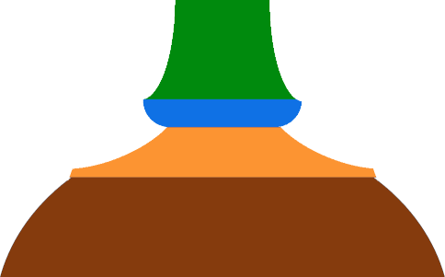

The collar was discussed above. Making one of these is standard rose engine lathe stuff.

You should not make this too ornate. Consider putting a single set of patterns on the top, and maybe also the side.

The rosette selected should coordinate with the one used for the Body and the Base.

As this will be a large piece, consider increasing the amplitude.

# Bamboo Finial

I call this the bamboo finial as it reminds me of a piece of bamboo.

It has a nice look and looks like an Asian design. It is a bold design which would need to be used on a large vessel.

This is a prototype, for which cherry is a great choice.

This finial can be made using a cross slide; no linear slide is required.

### Overall

|  |  |  |  |
| --- | --- | --- | --- |
| **Height** | 6” | **Diameter** | 1.5” |

### Body

|  |  |
| --- | --- |
| **Rosette** | GDP-3 with 50% phasing |
| **Cutter** | Horizontal Cutting Frame  6mm bit  2” swing diameter for the cutter |

Phasing each set of cuts 50% is what imparts the bamboo look. Potentially, a 33% rotation would do the same.

### Base

|  |  |
| --- | --- |
| **Cutter** | Drilling Spindle  Router bit used for round-over cuts. ¼” cut radius |

This base provides a nice, but small lift above the vessel.

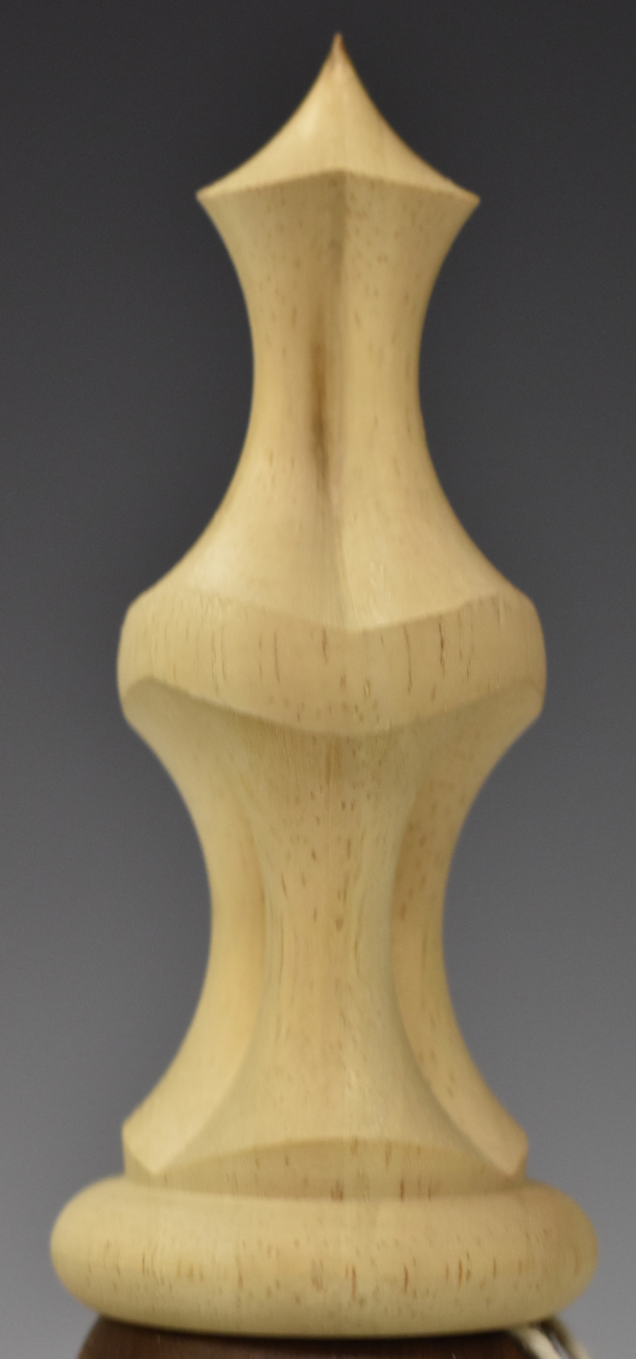This is another example of what I call a bamboo finial. As the picture shows, it is shorter and stouter.

This is another prototype, for which cherry is a great choice.

### Overall

|  |  |  |  |
| --- | --- | --- | --- |
| **Height** | 4.375” | **Diameter** | 1.75” |

### Body

|  |  |
| --- | --- |
| **Rosette** | GDP-3 with 50% phasing |
| **Cutter** | Horizontal Cutting Frame  6mm bit  2” swing diameter for the cutter |

By spacing between the two set of cuts, a wave is introduced. For this to work, a 50% phasing is recommended.

This wave was originally shaped on the traditional lathe where it was also sanded to a final finish.

### Base

|  |  |
| --- | --- |
| **Cutter** | Drilling Spindle  Router bit used for round-over cuts. ¼” cut radius |

This base was cut from both sides to provide the bead look. It is a very unique look, providing a definite separation from the vessel.

# Fluted Finial

This finial is a smooth set of flutes: In this case, 3.

This is a prototype, for which cherry is a great choice.

The making of this finial really needs a linear slide. A curvilinear slide makes it better by keeping the path curved.

### Overall

|  |  |  |  |
| --- | --- | --- | --- |
| **Height** | 4.25” | **Diameter** | 2.125” |

### Body

|  |  |
| --- | --- |
| **Rosette** | GDP-3 |
| **Cutter** | Horizontal Cutting Frame  6mm bit  2” swing diameter for the cutter |
| **Curvilinear Template** | #141 – 14” radius |

### Base

|  |  |
| --- | --- |
| **Cutter** | Drilling Spindle  Router bit used for round-over cuts. ¼” cut radius |

This base was cut from both sides to provide the bead look. It is a very unique look, providing a definite separation from the vessel.

# Helically Wrapped Finial Type 1

This finial incorporates the stepover into the design. The design seems to wrap around the body. Because it is so boldly done, the three elements (produced by the GDP-3 rosette) appear as if they were individually twisted.

This is a prototype, for which cherry is a great choice.

The making of this finial must have a linear slide for the Z axis. A curvilinear slide makes it better by keeping the path curved.

### Overall

|  |  |  |  |
| --- | --- | --- | --- |
| **Height** | 5.75” | **Diameter** | 1.25” |

### Body

|  |  |
| --- | --- |
| **Rosette** | GDP-3 |
| **Cutter** | Horizontal Cutting Frame  6mm bit  2” swing diameter for the cutter |
| **Curvilinear Template** | #141 – 14” radius |

### Base

|  |  |
| --- | --- |
| **Cutter** | Drilling Spindle  Router bit used for round-over cuts. ¼” cut radius |

This base provides a nice, but small lift above the vessel.

### Settings Used for the Body

Settings most affecting the shape are in **bold red**.

| Function | Roughing | Final Pass |
| --- | --- | --- |
| Index | * Index by Divisions * **5 Divisions** (of a circle) * Max speed = 5000 * Slider at 50% | * No change |
| Sync | * Helix Type = Right * Distance = 3.5” * Revolutions = 1.0 * Spindle   + Max speed = 5000   + Slider at 50% * Z Axis   + Max speed = 5000   + Slider at 100% | * Spindle   + Slider at 15% |

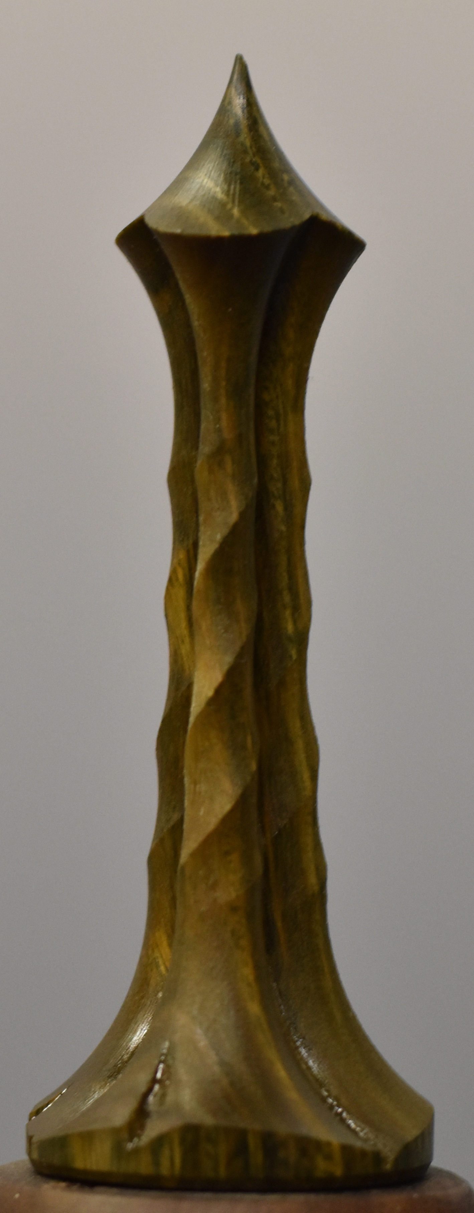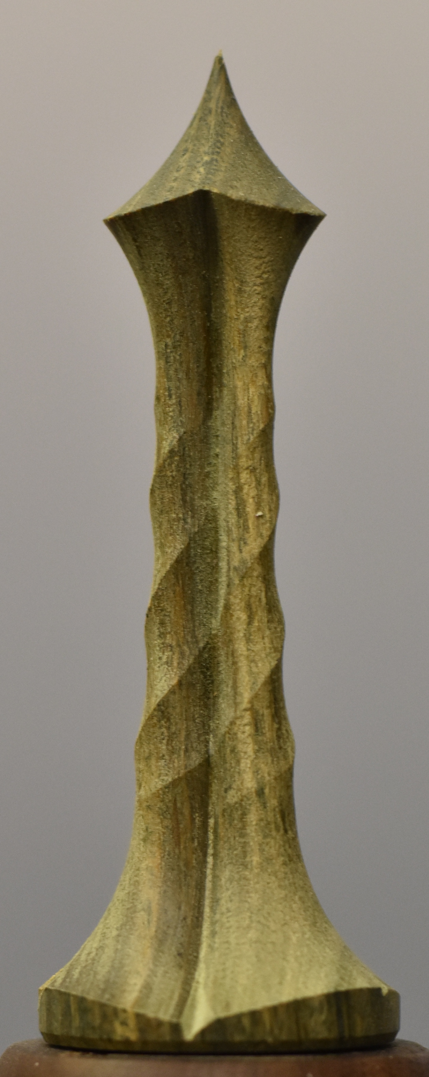The pictures to the right show a similar design but in lignum vitae. The left one is before a finish is applied, and the right after applying a single coat of Tried & True, Original.

|  |  |
| --- | --- |
|  |  |
| |  |  | | --- | --- | | **Height** | 4” | | **Diameter** | 1.75” | | **Divisions** | 5 | | |  |  | | --- | --- | | **Height** | 4” | | **Diameter** | 2” | | **Divisions** |  | |

The pictures to the right are examples of this same design, however these would be a part of multi-part finial.

Note how the arc of the cutter is such an integral part of the bottom of them.

The use of more divisions makes for a more delicate design.

### Settings Used for these Elements

The curvilinear template used for both is #182 – 4” radius.

| Function | Left Element | Right Element |
| --- | --- | --- |
| Index | * 5 Divisions (of a circle) | * 3 Divisions (of a circle) |
| Sync | * Helix Type = Left * Distance = 3.5” * Revolutions = 1.25 | |

# Helically Wrapped Finial Type 2

This finial has two elements. The lower element was chosen from a different wood to ensure a contrast with the vessel (which is walnut and is shown in a picture below).

The making of this finial really needs a curvilinear linear slide to keeping the path curved.

-----------------------------------------------------------

### Upper Element

### Overall

|  |  |  |  |
| --- | --- | --- | --- |
| **Material** - Bloodwood | | | |
| **Height** | 3.25” | **Diameter** | 1.5” |

### Body

|  |  |
| --- | --- |
| **Rosette** | GDP-3 |
| **Cutter** | Horizontal Cutting Frame  6mm bit  2” swing diameter for the cutter |
| **Curvilinear Template** | #111 – 8” radius |

### Base

|  |  |
| --- | --- |
| **Cutter** | Drilling Spindle  Router bit used for round-over cuts. ¼” cut radius |

This base provides a nice, but small lift above the vessel.

-----------------------------------------------------------

### Lower Element

### Overall

|  |  |  |  |
| --- | --- | --- | --- |
| **Bottom Element** – Hard Maple | | | |
| **Height** | 2” | **Diameter** | 1.5” |

### Body

|  |  |
| --- | --- |
| **Rosette** | GDP-3 |
| **Cutter** | Horizontal Cutting Frame, 6mm bit, 2” swing diameter for the cutter |
| **Curvilinear Template** | #111 – 8” radius |

### Base

|  |  |
| --- | --- |
| **Cutter** | Drilling Spindle  Straight router bit, 2 flute, 1/4" wide. |

This base provides a nice, but small lift above the vessel. This had to be under-cut with a triangular bit. This was to accommodate the shape of the top of the vessel.

### Settings Used for the Upper Element of the Body

Settings most affecting the shape are in **bold red**. The [**Dynamic Rosette Phasiing calculator**](https://mdfre2.colvintools.com/MSMCSv3/MDFRE-2.0-Activity-RPMCalc.html) was used for the MultiSync values,

For this, the UCF was set at 11.8º.

|  |  |  |
| --- | --- | --- |
| Function | Roughing | Final Pass |
| MultiSync | * **Z Axis**   + Direction = Arrow      Description automatically generated   + Target = 1.25”   + Max speed = 5000   + Slider at 100% * **M3**   + Direction = **Icon      Description automatically generated**   + Target = 4,440°   + Max speed = 5000   + Slider at 50% * **Spindle**   + Direction = **Icon      Description automatically generated**   + Target = 4,500°   + Max speed = 5000   + Slider at 100% | * **Z Axis**   + Slider at 15% * **M3**   + Target = 44,940° * **Spindle**   + Target = 45,000° |

For the lower element, traditional Sync was used.

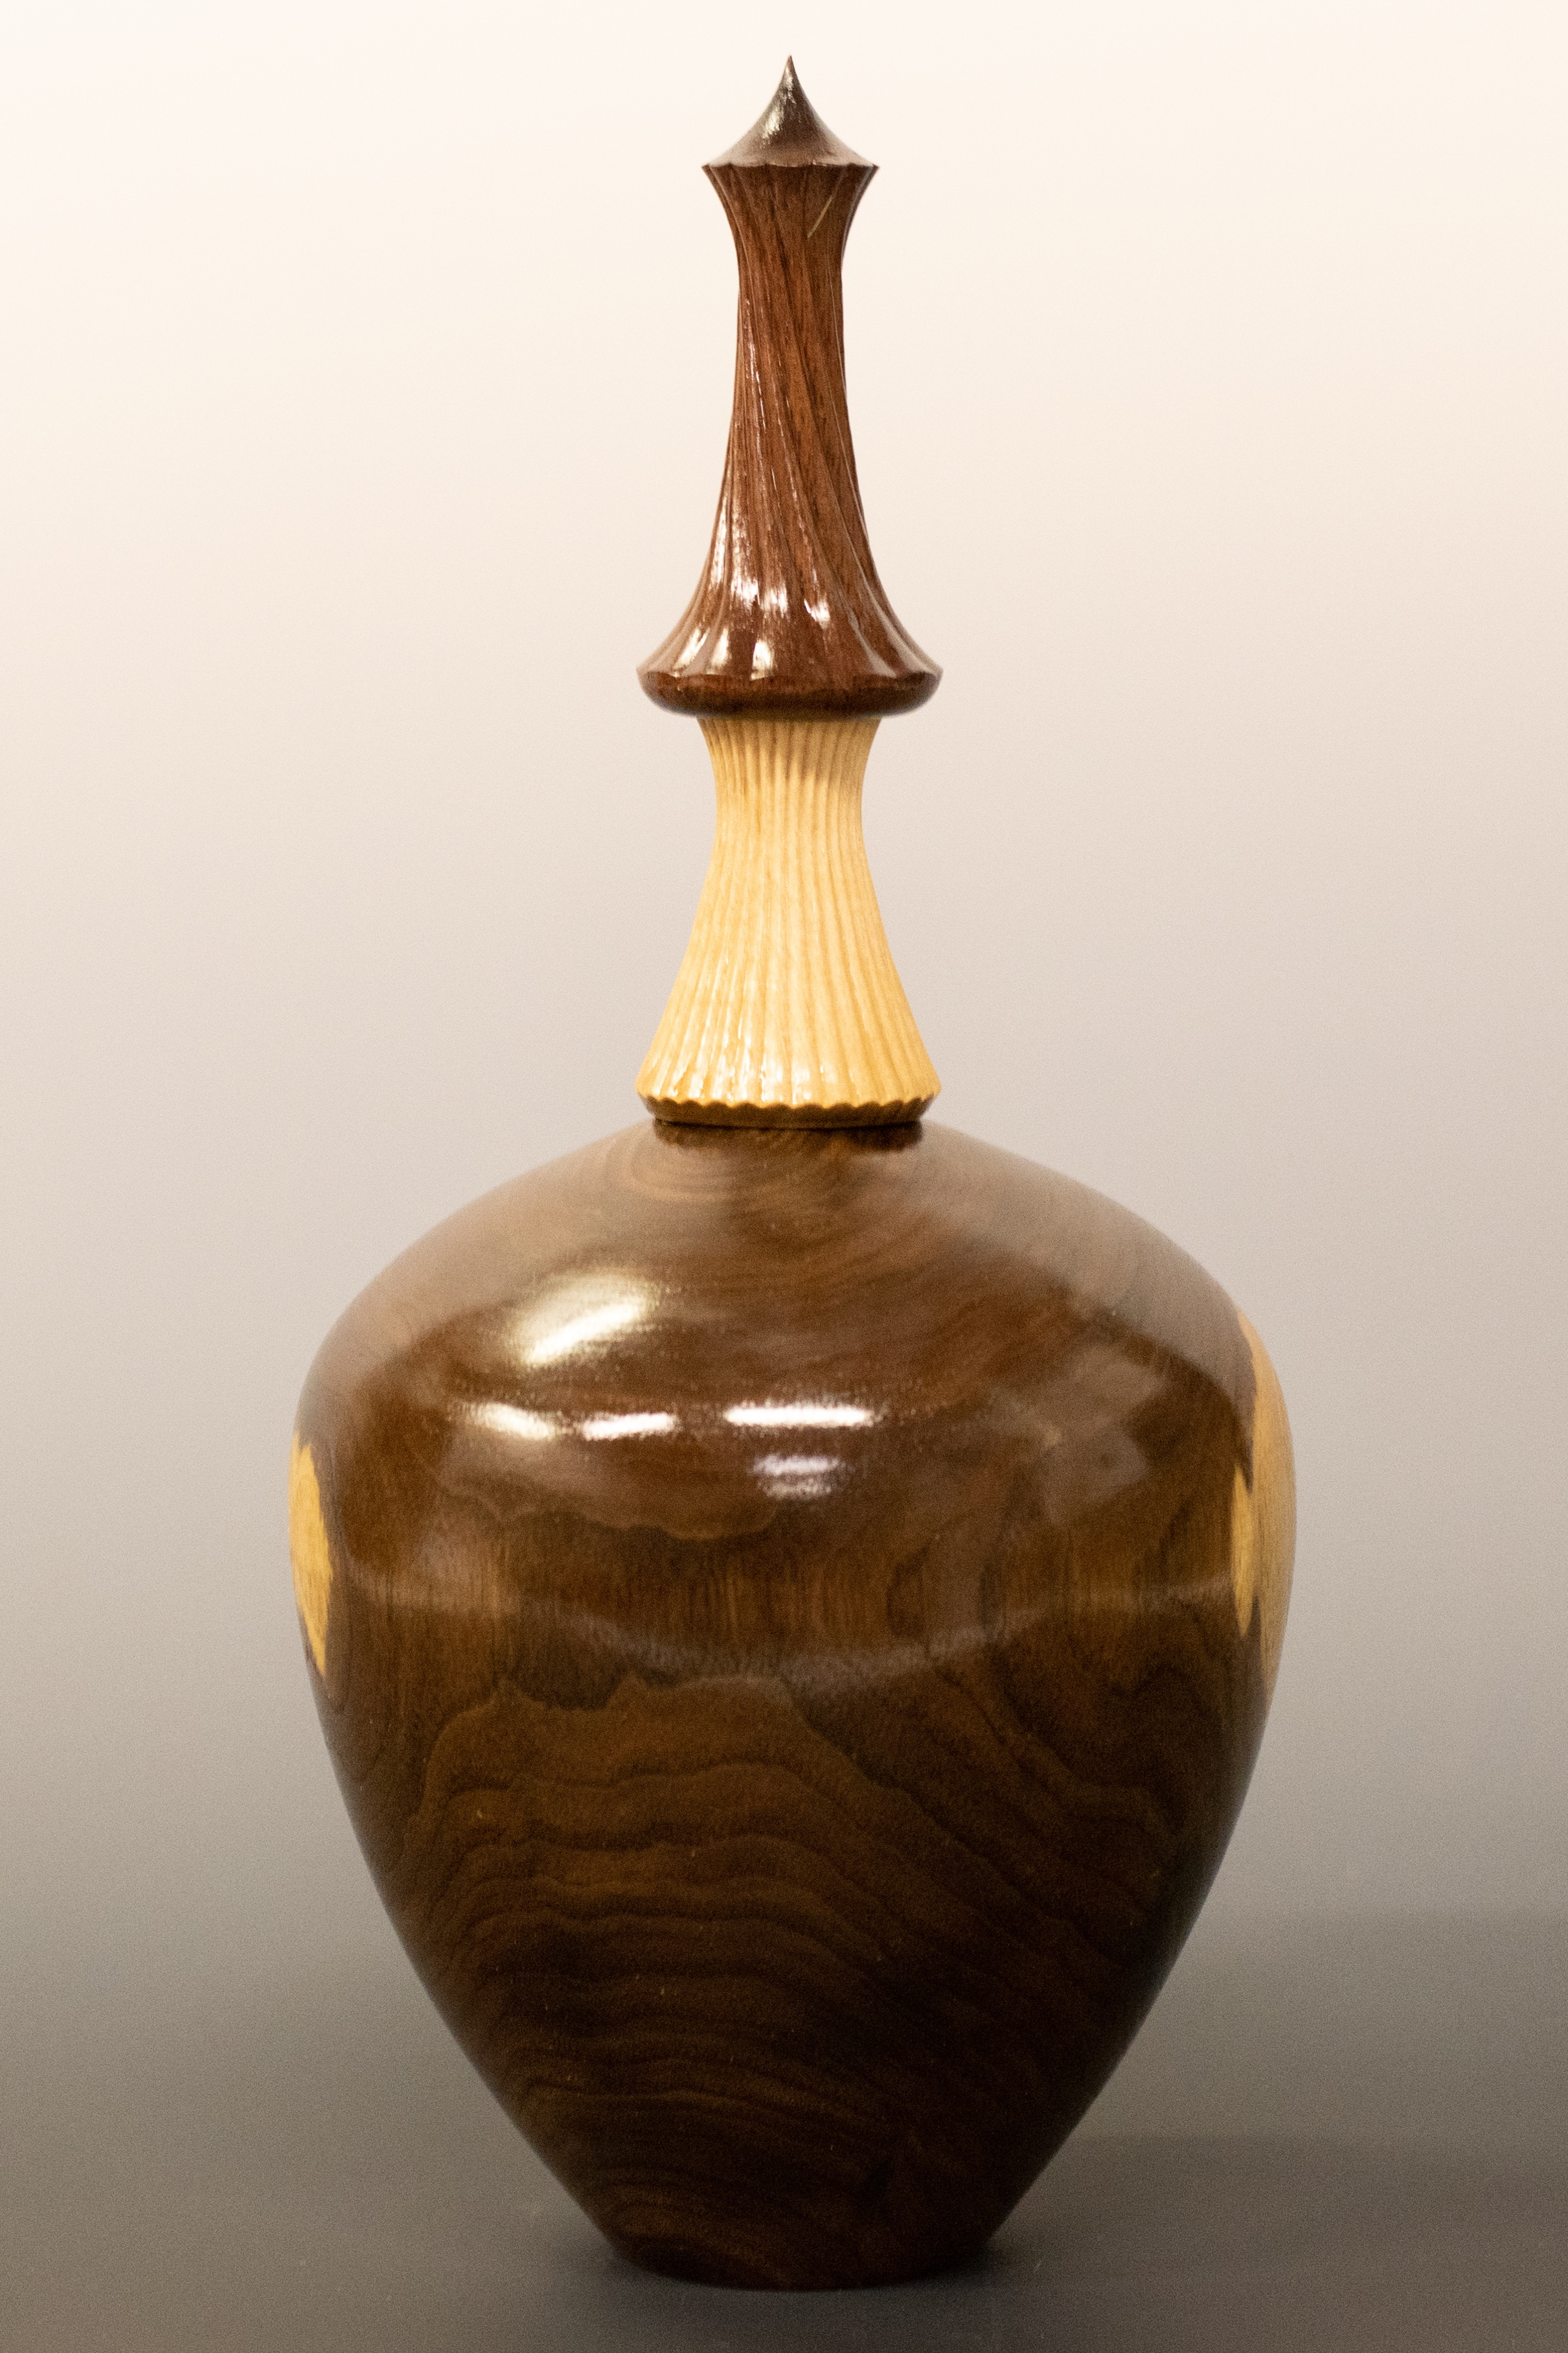This finial was designed for the vessel it is atop – in the picture to the right.

**Finial:** Bloodwood & Hard Maple

**Vessel:** Walnut

These are two additional examples of similar finials on vessels.

|  |  |
| --- | --- |
| **Finial:** Padauk  **Vessel:** Box Elder | **Finial:** Padauk & Maple  **Vessel:** Box Elder |

To the extent that material may appear to be infringed, we assert that such alleged infringement is permissible under fair use principles in U.S. copyright laws. If you believe material has been used in an unauthorized manner, please contact me at [ColvinTools@Gmail.com](mailto:ColvinTools@Gmail.com).